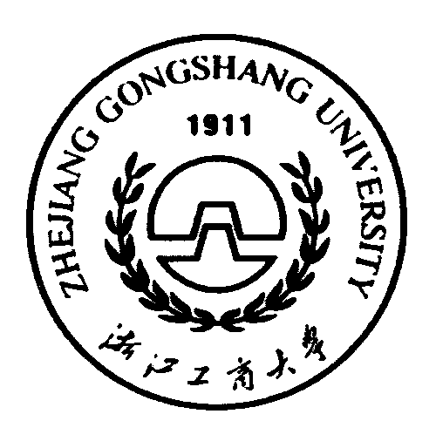


ZHEJIANG GONGSHANG UNIVERSITY

Address：No.18, Xuezheng Str. Xiasha University town 310018, Hangzhou, Zhejiang, China
